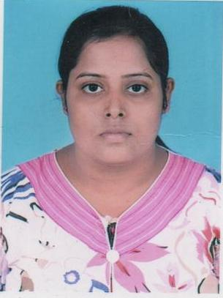
Curriculum Vitae

Lovely Kumari Ojha
New Ashok Nagar, Delhi
E-mail –lovely.ojha7@gmail.com
Mobile No- 9911219310,9560102626

Career Objective

Looking for a suitable position in a people-oriented organization where I can utilize my energy and skills in challenging environment to achieve the corporate goals.

Work Experience

Worked as a Sales Coordinator in Somany Ceramics May2016-July 2016

Responsibilities Handled:
Making BTL budgets in ERP
Coordinate with the sales team and maintain reports.
Approve Travel expense

Worked as a Sales Coordinator in Mayfair Lightings & Poles Aug 2015-Jan 2016

Responsibilities Handled:
Making and sending quotations to the customers
Making Purchase Order, Performa Invoice
Maintaining MIS in excel
Coordinate with the sales team and maintain reports.

Worked as Computer Operator at SSK Associates for 6 months

Educational Qualifications

- PGDM/MBA from Accurate Institute of Management & Technology, Greater Noida with IT and Marketing Specialization 2015
- B.Sc (IT) from Kuvempu University 2012
- 12th from DAV Mahila College from JACR Board 2009
- 10th from DPLMA School from JACR Board 2007

Academic Projects
SIP Location: Paras Diary
SIP Project Title: Customer Satisfaction in Mobile Communication Industry in India .
Duration: 2 Months (May- July)
Computer Skills & certifications

Certified from NIIT Technologies for Course Titled : Infoedge-certificate of Competency in Computing

Done Accounting with Tally.ERP.9 from NIIT Technologies

Strength
- Interpersonal skills
- Networking
- Self-Motivated

Hobbies
- Cooking
- Playing Badminton

Achievements

District topper in Graduation -B.Sc (IT)
Got Certificate of Appreciation in the Event Money Multiplier at Accurate Institute of Management & Technology

Personal Detail
Father’s Name : Mr.Nitya Ranjan Ojha
D.O.B : 10 March 1992
Marital Status : Single
Languages Known : English, Hindi, and Bengali
Gender : Female
Hometown : Dhanbad, Jharkhand

I hereby declare that the above-mentioned information is correct up to my knowledge and I bear the responsibility for the correctness of the above-mentioned particulars.

Place: Delhi Lovely Kumari Ojha

